Dentistry – a high risk activity?
Maintenance and strengthening fragile protective barriers – an important issue for all dental health care professionals
By Dr Mikael Zimmerman DDS, PhD, associate professor

Oral health and general health!
Oral health must be recognized as an integral part of general health and essential to the quality of life. Many suffer from pain and discomfort due to the burden of oral diseases. Caries, periodontal diseases and several other oral conditions are linked to diet, nutrition, lifestyle, oral hygiene and behavioural factors.
Oral health means much more than just healthy teeth. The oral cavity is a gateway to the rest of the body, and if left untreated even for a short period of time, oral diseases can have adverse consequences. They are considered a risk factor in a number of general health conditions. The systemic spread of bacteria can cause, or seriously aggravate, infections throughout the body, particularly in individuals with a suppressed or impaired immune systems.

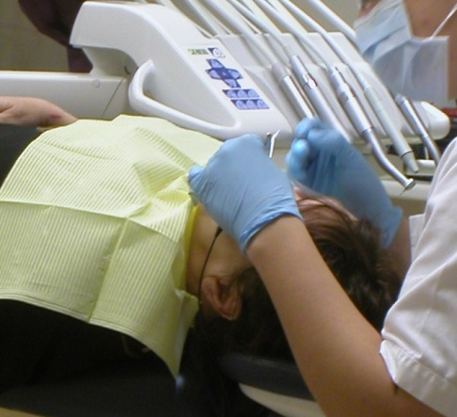
Picture 1: With increasing knowledge about the risk of transmission of infection and about hygiene, all types of care can be provided under safe, hygienic conditions that minimize the risk of transmission of infection.

The roles of the first and second line of defence.
Our immune defence is comprised of a first and a second line of defence mechanisms. The first line of defence consists of the human body’s protective barriers such as the skin, the mucous membranes, and the enamel/dentin of the teeth. As long as these barriers are intact and well functioning, it is very difficult for microorganisms to penetrate into sensitive tissues and life important organs and functions.
The immune defence carried out by our white blood cells and other immunoactive cells are referred to as the second line of defence. When the second line of defence starts acting, the intruder is already in “the wrong place” and can start multiplying and cause adverse effects on life supporting systems. When microbial intruders have entered into the human body there will be a battle between the immune systems second line of defence and the microorganisms until either one has conquered the other.
Infection requires that all three of the following conditions be present:
1) a susceptible host
2) a pathogen with sufficient infectivity and numbers to cause infection
3) a portal (door) through which the pathogen may enter the host.
Effective infection-control strategies are intended to break one or more of these "links" in the chain, thereby preventing infection. There are several ways to make sure that individuals are less susceptible to infections: in general through vaccinations but also by strengthening protective barriers.

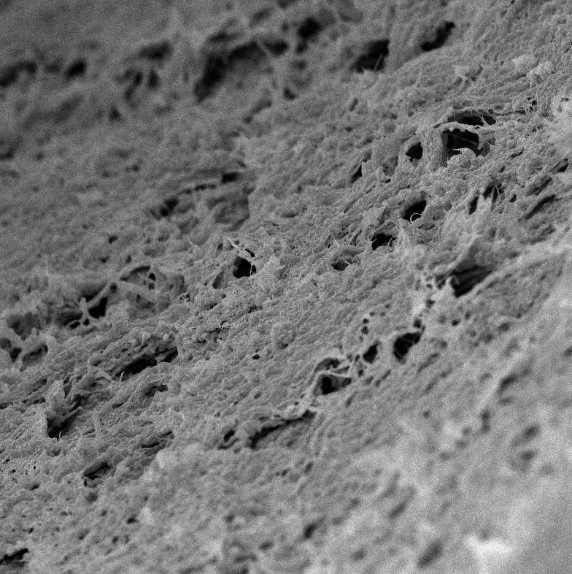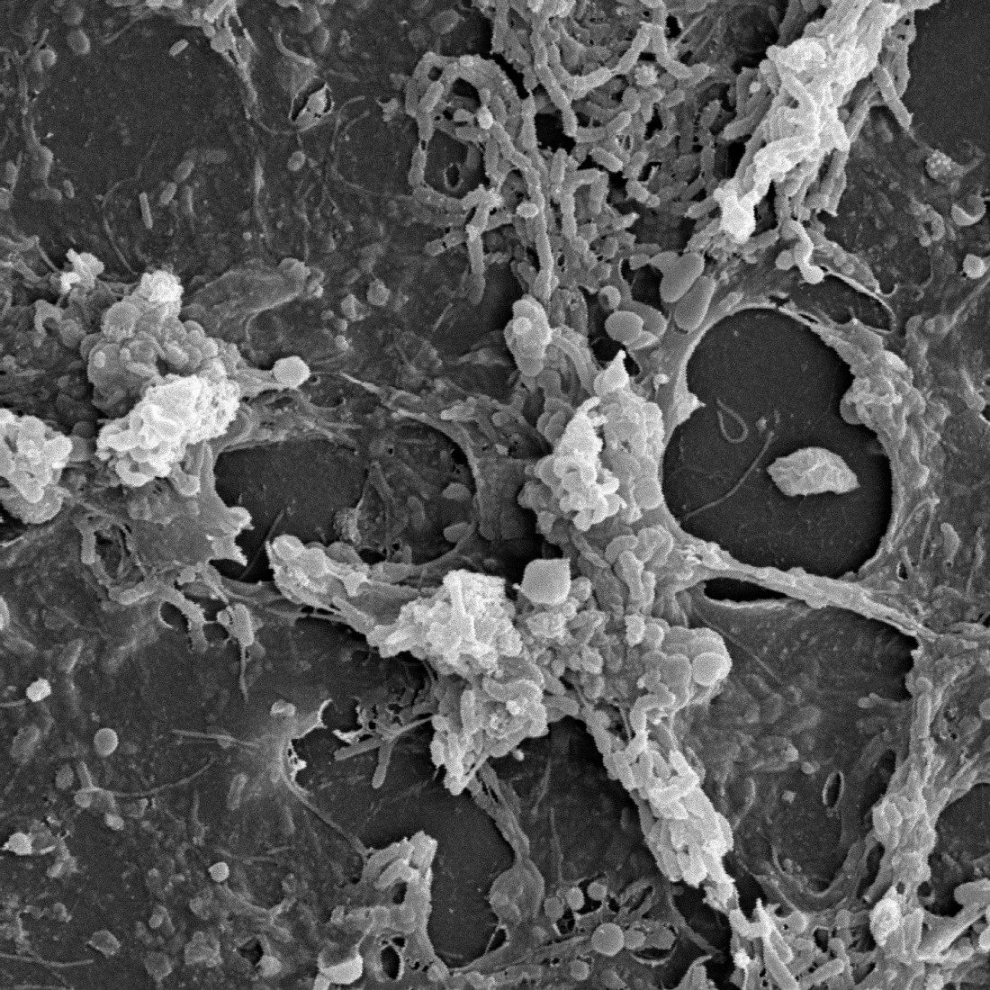
Picture 2 and 3: Bacterial biofilms can be found on all surfaces – teeth and oral mucosa – from which bacteria as well as bacterial toxins can be introduced into previously sterile compartments if the first line of defence will be weakened or broken.

Be careful with protective barriers!!
Reducing the number of microorganisms in an area by for example proper oral hygiene will make sure that what is left of the microorganisms will not be sufficient to cause infection. Once there is an open door through which a pathogen may enter the host, it is vital to protect this as much as possible, by keeping the area clean, by closing the wound with meticulous suturing and, by facilitating the process of getting good blood coagulation in the area in question.

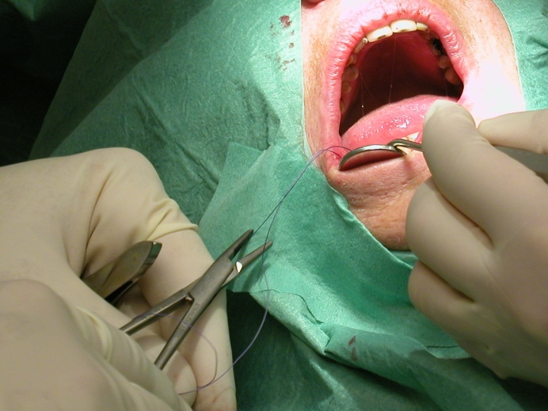
Picture 4: Prudent wound handling must comprise all possible measurements to re-establish a well functioning first line of defence. This includes, among other things, adequate suturing, membrane techniques, handling of blood coagulation, the use of antimicrobials, etc...

All these precautions will aim at strengthening the human body’s own defensive barriers, in addition every patient undergoing treatment procedures where barriers will be penetrated must be carefully evaluated and proper precautions considered.
In all health care situations, it is important to consider the consequences of opening, penetrating or altering fragile barriers. A key issue, for the success rate of both simpler and more advanced therapies, is to maintain, strengthen or be as careful as possible with important protective functions. Hygiene and infection control in clinical dentistry must encompass not only the risk of transmitting infection, but also susceptibility to infection as well as evaluation of exposure-prone procedures and instruments. All efforts in maintaining fragile biological barriers will also reduce excessive or unnecessary use of antibiotics.

Daily oral hygiene can be more important than prophylactic antibiotics!
For several groups of patients, practicing daily oral hygiene is more important than taking preventive antibiotics before a dental visit. Proper oral hygiene is a simple and effective way of strengthening important protective barriers. For patients at risk, regular and very frequent dental visits including professional tooth cleaning and polishing can have a large medical impact on their well being – just by keeping gums healthy and thereby maintaining their function as a protective barrier in the first line of defence. A general gingivitis represents an open wound, equal in size to the palm of a hand. It is not difficult to realize the medical importance of such a wound in any parts of the body – dentistry needs to recognize the general health hazards associated with such a large scale of opened entrance to fragile systems.
Per definition gingivitis is not an infection but rather an inflammatory reaction against microbial toxins produced by microorganisms residing in the oral biofilms (dental plaque). This inflammatory process will weaken the fragile and important protective barrier that a healthy and non-inflamed gingival tissue will provide.

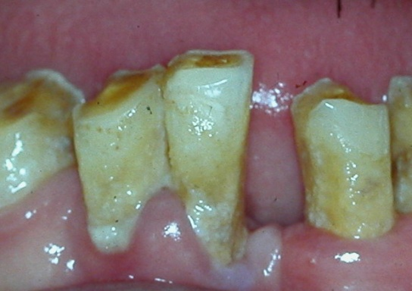
Picture 5: Daily oral hygiene procedures combined with regular professional tooth cleaning and polishing will have important clinical implications in keeping numbers of microorganisms down and strengthening the patient’s first line of defence.

Increased susceptibility by age
With age, there is a decline in the reserve capacity of the body’s various organs and systems. These changes begin as early as in the twenties and continue steadily, and are determined by lifestyle and genetic factors. Increased age usually means a variety of health problems, which leads to a number of different medications. In addition, the diet of many elderly people is not infrequently monotonous and because of their more sedentary lifestyle, their nutritional intake is also lower. All of these factors will naturally increase susceptibility to different kinds of health problems. An infectious disease, for example, will have a greater debilitating effect on an older person.

Impaired immune response due to diseases and medications.
Immunodeficiencies can often be seen in relation to an underlying disease such as cancer or autoimmune disease. Many patients have a depressed or slightly altered immune system because of the therapy used to treat certain diseases. Opportunistic infections caused by the normal flora may occur when the immune response is impaired and can be fatal if not diagnosed and treated.

Malnutrition and metabolic syndrome.
Malnutrition is not only seen in individuals with too low a food intake, but also in patients with metabolic syndrome, i.e. obese patients with increased waist circumference, hypertriglyceridemia, low HDL cholesterol level, hypertension, and hyperglycemia. The altered metabolism will, among other things, lead to increased susceptibility to infections.

Drug addiction – a common problem with many consequences
The possibility that health care workers, including the dental professionals, unknowingly treat drug addicts in their daily practice among other patients is great. Less than 10% of all drug abusers worldwide are “open and evident” cases. The abuse of drugs may include the legal or illegal use of narcotic drugs, alcohol, tobacco, pharmaceuticals or other chemical substances.
Because of the regular use of drugs, drug addicts represent a wide range of possible medical hazards and complications. These individuals have impaired systemic functions. This could be caused by direct or indirect drug effects, malnutrition, impairment, deficiencies, infectious diseases etc. Other problems with drug abusers are increased incidence of dental caries. The treatment of multiple cavities puts the dentist in a difficult situation.

The oral cavity – our most microbial populated organ!
The oral cavity is the organ with the relatively largest population of microorganisms, both in number and variety. Most oral microorganisms belong to the natural, resident flora and have an important protective role for our immune defence against pathogenic microorganisms. Groups of microorganisms known to cause disease may appear transiently in the oral cavity. Dental caries and periodontal diseases are almost exclusively caused by microorganisms that occur in the oral cavity, and may therefore be regarded as endogenous opportunistic infections.
Bacteraemia – a daily problem.
During dental treatment, both normal and transient microflora may be introduced into sterile tissue during instrumentation or transmitted between individuals via instruments or hands of the operator. During several procedures in the oral cavity, even toothbrushing and flossing, different bacteria will enter into the bloodstream – bacteraemia – if the protective barriers are weakened or broken. For healthy individuals with normally functioning immune defence system, this will rarely pose any problems. In persons with different types of immune deficiencies or otherwise increased susceptibility for infections, oral/dental treatments could cause serious complications.

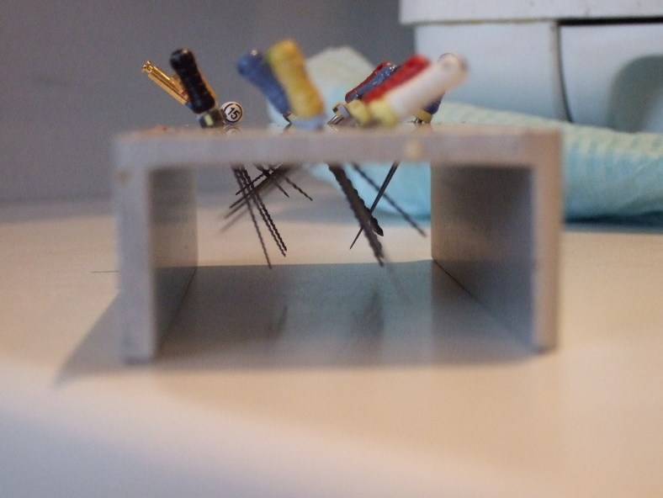
Picture 6: Dental treatment procedures include the use of several different cutting and penetrating instruments.

Dental caries, the world’s most common infectious disease.
From a global perspective, dentin caries is still the largest infectious disease in prevalence affecting the vast majority of the world´s populations. The most common procedure that the dental practitioner conducts in all groups of patients is the treatment of dental caries. In many countries, access to oral health services is limited and teeth are often left untreated or are extracted because of pain or discomfort. After a tooth extraction, pathogenic microorganisms from the oral cavity have an open gateway into previously sterile tissue far beyond the defence barriers. A basic principle in the provision of dental care is that as far as possible, the risk of transmitting infection should be minimized.

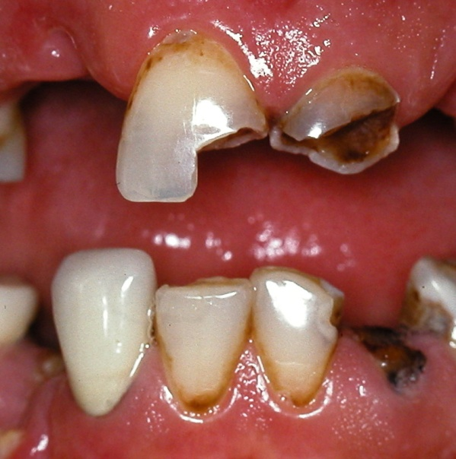
Picture 7: Dental caries, still the world most common bacterial infection. Caries causing bacteria can be very aggressive not only in the oral cavity, but also in other parts of the body – if allowed to enter by passing the first line of defence!

To be as atraumatic as possible.
Tooth extraction is rarely a simple procedure. A successful extraction is when the entire tooth is removed with a minimum of trauma to the adjacent, remaining tissues. To achieve this, the best success rate includes knowledge of tooth morphology, correct choice of technique, and the use of appropriate equipment.
Following invasive dental procedures, microorganisms which are normally resident in the oral cavity can, under certain conditions, give rise to infections in other parts of the body. In a Swedish study bacteremia was observed in 100% of the patients after dental extraction. Bacteremia was not related to the extent of surgery, since a single dental extraction produced a higher incidence of bacteremia than third-molar surgery and bilateral tonsillectomy did. It appeared that dental extraction was associated with both aerobic and anaerobic bacteremia significantly more often than the other procedures were. The explanation for this is obscure, but heavy colonization of the tooth surfaces with aerobic and anaerobic microorganisms in combination with the pumping movements used in dental extraction may be of importance.

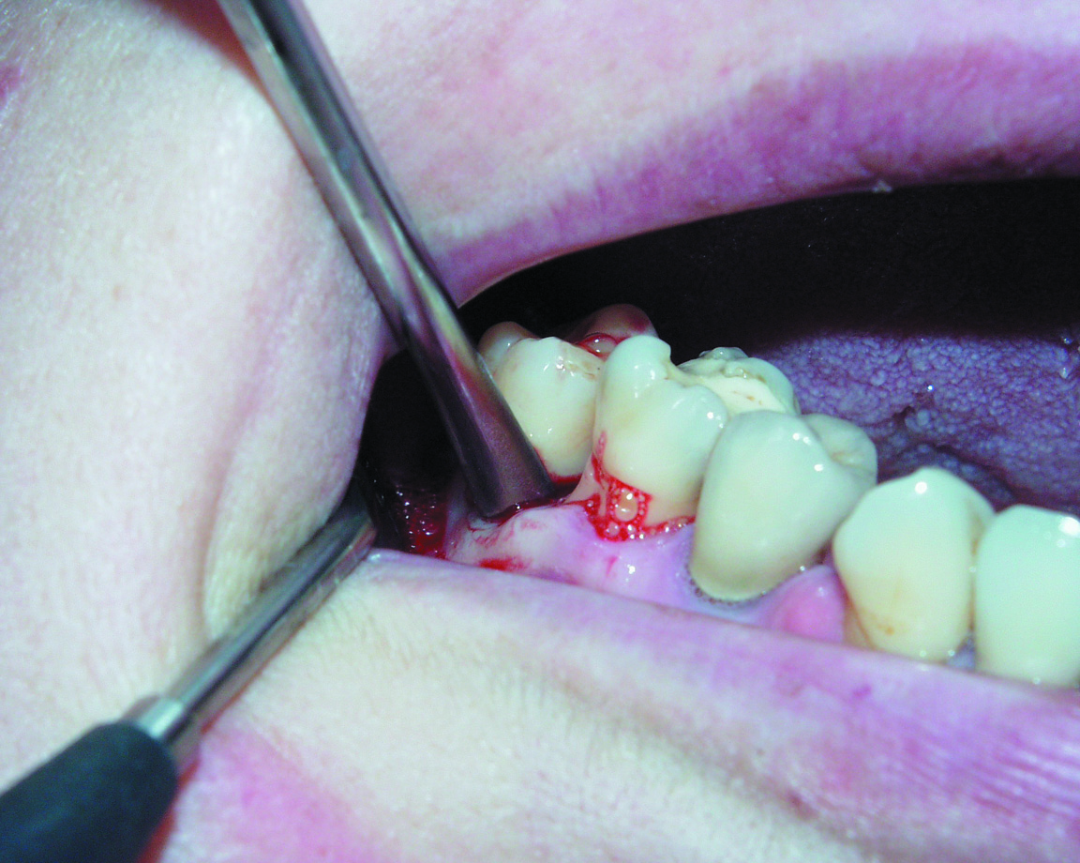
Picture 8: Fast, simple and atraumatic techniques will be of great importance. This will require sophisticated instruments as well as good clinical skills. (Picture Courtesy of: Directa,, Sweden)

Subgingival irrigation and cleaning to reduce the risk for bacteraemia.
When carrying out periodontal treatments, pre-procedural subgingival irrigation before ultrasonic scaling can significantly reduce the level of bacteremia associated with ultrasonic scaling. The same precaution should be taken before extracting teeth.
Certain bacteria require the presence of oxygen in order to grow (aerobic bacteria). A large group of bacteria requires a completely oxygen-free environment (anaerobic bacteria). The anaerobes are less likely to survive outside the host organism. Within dentistry the anaerobic bacteria are more often disease causing, which is one of the reasons for “opening infections” and letting the air in – exposure to oxygen will kill the harmful bacteria. In dentistry this is one of the important functions with subgingival cleaning and scaling.

Oxygen can make a large difference.
Letting the air (oxygen) in is also one of the major reasons for surgical intervention to open abscesses and maintaining good drainage during the process of healing.
Cutting and finishing approximal preparations with conventional rotating instrumentation and methods may produce iatrogenic damage in adjacent tooth surfaces. Preparation damage is a frequent side-effect in the preparation of approximal caries lesions, and represents a dental health problem. Preparation damages destroys the protective enamel/dentin barrier which in turns increases caries progression and the need for restorative therapy of the adjacent tooth.

Damages on the first line of defence due to preparations.
Dental preparations involving minor marginal gingival injuries through cutting rotation forces from the drill and the high-pressure flow of water from turbines and handpieces will have the same effect as getting multiple injections including biological material from unclean injection needles.
The use of protective wedges is a very simple way of protecting sensitive barriers such as enamel/dentin and gingival margin

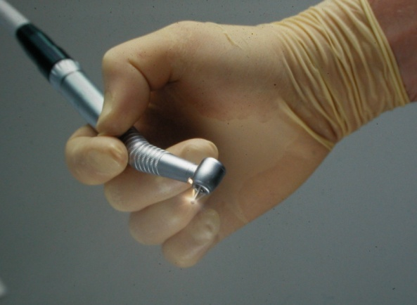
Picture 9: Dental high-speed preparation will have the similar effects on the first line of defence as multiple needle injections.

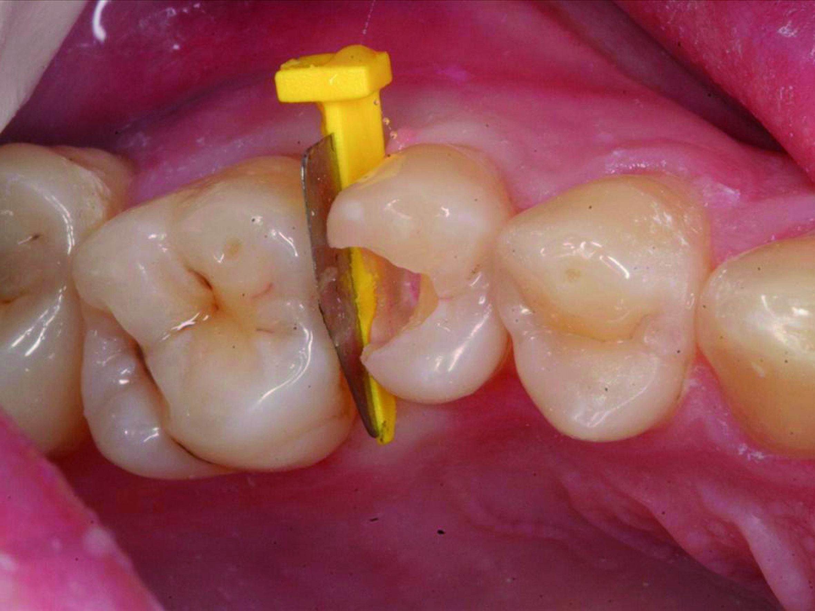
Picture 10: Protective wedges are a very simple way to protect the first line of defence (enamel of the teeth) of the adjacent tooth. Several scientific studies have showed that the neighboring tooth surface will be damaged in a substantially high number of cases when doing approximal preparations. This will result in an increased susceptibility for dental caries. (Picture Courtesy of: Directa, Sweden)

Keep microorganisms in place.
Healthcare providers have very delicate professional responsibilities. Modern healthcare has every possibility to provide patients with medical good care, including high safety and quality. The most important infection protection is the presence of intact barriers. The purpose of an adequate barrier protection should be to keep microorganisms in their proper place and thereby preventing disease transmission. Secondly keep microorganisms from growing to harmful numbers, with appropriate aseptic techniques. If all these measures are not successful, and the microorganisms are allowed to enter into previously sterile tissues and establish an infection, antimicrobial therapy can be necessary. Most antibiotics are bacteriotstatic, keeping bacteria in a lower number by interfering with their ability to multiply, thereby giving the second line of defence a better chance to organize counter attack. The infectious condition will be solved by the immune system with some help from antibiotics.

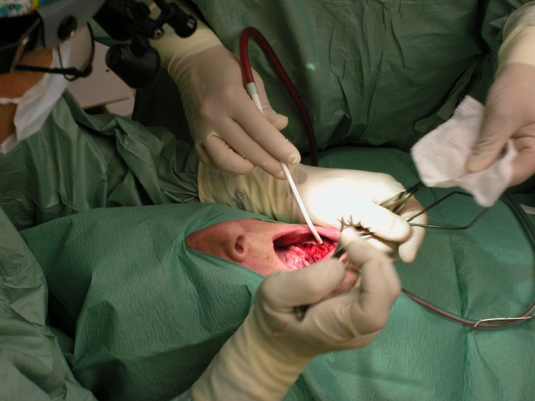
Picture 11: Aseptic techniques must aim at keeping the microorganisms in place and at the same time have a very great respect for the first line of defence.

Healthcare associated infections will jeopardize treatment outcomes.
Healthcare-associated infections cause tremendous additional costs, increase antibiotic resistance, jeopardize treatment outcomes, prolong patient suffering, decrease treatment capacity and create ‘bad-will’ for healthcare providers. The care provider must make sure that all patients should be able to get dental care with the best possible quality, the greatest possible safety, and with as few side effects as possible.

Strengthening the fragile barriers!
A critical issue will be the care providers knowledge about and attitudes towards maintaining and strengthening the fragile defence barriers comprising the first line of defence – restorative dentistry, the making of filings, will actually be a way of strengthening barriers. All dental procedures must aim at the same result – maintaining or strengthening fragile protective barriers -- in order to be effective.

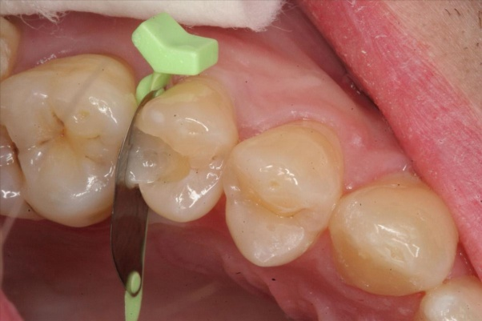
Picture 12: The reconstruction – restorative treatment – will not only recreate function and esthetics, but at the same time rebuild the important first line of defence. The critical issue for the clinician will be to make sure that the quality of the filling must be as close as possible to the original capacity of the lost tooth structure to function as an important part of the first line of defence! (Picture Courtesy of: Directa, Sweden)

References:
Fine DH, et al. Assessing pre-procedural subgingival irrigation and rinsing with an antiseptic mouthrinse to reduce bacteremia. J Am Dent Assoc. 1996 May;127(5):641-2, 645-6.
Fine JB, et al. Short-term microbiological and clinical effects of subgingival irrigation with an antimicrobial mouthrinse. J Periodontol. 1994 Jan;65(1):30-6.
Heimdahl A, et al. Detection and quantitation by lysis-filtration of bacteremia after different oral surgical procedures. J Clin Microbiol. 1990 Oct;28(10):2205-9.
Lewis D.L., et al. Resistance of microorganisms to disinfection in dental and medical devices. Nature Medicine, Vol 1 No 9, Sept 1995, p 956-958.
Lussi A, et al. Iatrogenic damage to adjacent teeth during classical approximal box preparation. J Dent. 1998 Jul-Aug;26(5-6):435-41.
Lussi A. Damage to neighboring teeth during the preparation of proximal cavities. Anin-vivo study [Article in German] Schweiz Monatsschr Zahnmed. 1995;105(10):1259-64.
Medeiros VA, et al. Iatrogenic damage to approximal surfaces in contact with Class II restorations. J Dent. 2000 Feb;28(2):103-10.
Qvist V, et al. Progression of approximal caries in relation to iatrogenic preparation damage. J Dent Res. 1992 Jul;71(7):1370-3.
Ruvo AT, et al. The impact of delayed clinical healing after third molar surgery on health-related quality-of-life outcomes. J Oral Maxillofac Surg. 2005 Jul;63(7):929-35.
Toschimichi Mori, et al. Luxator® a new instrument for Tooth Extraction. The Nippon Dental Review 2004;12 Vol 64/12:746

