 PRACTICAL DENTISTRY

Effective intraligamental anesthesia

using systems

for computer anesthesia

**Aneta Olszewska**



**Effective intraligamental anesthesia for dental procedures**

University Center of Dentistry and Specialist Medicine, Clinic of Facial Developmental Defects,

Poznań University of Medical Sciences

Head of the Outpatient Clinic for Pediatric Dentistry: Aneta Olszewska M.D.

*Abstract*

*The commonly used techniques for local anesthesia used in dental procedures are mainly infiltration and block anesthesia. These types of anesthesia are often unpleasant for the patient, as they lead to delivering too much anesthesia in relation to the extent of the procedure. When deciding on the delivery of anesthetic for a single tooth, we expose the patient to a temporary sensory disorder in half of the tongue, the lips or cheek, which persists for some time after the procedure ends. Conventional methods of anesthesia also encounter the problem of the patient’s fear of the needle and syringe. Currently, the aim is to obtain a method of delivering the anesthetic that would cause the least possible discomfort, be painless, atraumatic, with high analgesic efficiency, and as a result, well‑accepted by the patient. For this reason, in recent years, in all dental specialties, computer systems for the delivery of intraligamental anesthetic have been used more and more frequently, allowing to obtain anesthesia for individual teeth and only the nearest, neighboring tissues.*

**Key words: intraligamental anesthesia, periodontium, CCLAD computer controlled local anaesthetic delivery system**

PDL anesthesia (periodontal ligament anesthesia)

In the mouth, with or due to elasticity (cohesiveness), 3 types of tissues are distinguishes: type 1 - low compaction, the anesthetic solution is subject to diffusion under minimal pressure (e.g. the oral mucosa of the cheeks ); type 2 - medium compaction (attached gingiva, mucous membrane on the palate), medium pressure of delivery is required; and type 3 - high compaction, high pressure is required for delivery (periodontal membrane). Due to the lack of elasticity in the periodontal membrane, the fluid should be initially pumped into the periodontal membrane crevice, from where it is subject to diffusion within the vascular and nutritional canals in the tooth socket bone. To prevent the formation of excessive pressure on the periodontal ligament, during injection the speed of delivery of anesthesia must be slow. The injection site should allow free diffusion of the fluid without the risk of producing too high pressure.

Creating the appropriate pressure of the anesthetic allows the fluid to penetrate through the openings in the bone of the tooth socket. The bone surrounding the roots of the teeth with the small openings that are present in it constitutes a barrier. If the fluid is delivered at

58 Magazyn StoMatologiczny No. 6/2019

the right pressure at a constant and low speed, it moves within the opening and penetrates through the bone.

If the pressure is too high or the time of delivery too short, the fluid creates a barrier - slowing down or preventing diffusion

- which reduces the effectiveness of the anesthesia. If the speed of delivery is too fast, the stream of the fluid is unable to penetrate the cancellous bone, it is reflected from the surface of the compact bone and flows out of the gingiva crevice.

Failure to take into account the varying vulnerability/elasticity of the tissue and the adaptation features may lead to ineffective intraligamental anesthesia as well as increases the risk of damage to tissues due to excessive pressure of the fluid, such as localized ischemic necrosis or

tooth extrusion.

Computer-assisted delivery of anesthesia make it possible to control the speed of delivery and the pressure in the tissues, which can be seen on the panel of the display in the form of visual (diodes) and sound signals. The safety of intraligamental anesthesia when using such devices makes it possible to stop and discontinue the delivery of the fluid if the pressure in the tissues is too high.

Indications for intraligamental anesthesia constitute, for example, clinical situations such as: the treatment of teeth on opposite sides of the arc so as to avoid the effect of anesthetizing both sides, procedures on children (helps avoid the anesthesia of soft tissues and the occurrence of self-injury), procedures on patients with contraindications for block

anesthesia (e.g. hemophilia sufferers), during surgical procedures to obtain better hemostasis, as auxiliary diagnostic anesthesia (to locate pain), when putting on retainers, orthodontic rings, etc. and as additional anesthesia during ineffective block anesthesia.

The contraindications for intraligamental anesthesia are infections or acute inflammation around the injection area. This may result in failure to achieve anesthesia. In the case of infection or inflammation of tissue at the injection site, as a result of pH changes and the vasculature of periodontis tissues, there is a lower effectiveness of local anesthesia. Injecting the needle into the periodontal space where an inflammatory process is underway causes serious danger of

the spread of bacteria.

The advantages of intraligamental anesthesia:

* prevents anesthesia of the lip, tongue and cheek, which makes treatment easier in several quadrants during the same visit



Fig. 1. Area of PDL anesthesia.

* in order to obtain anesthesia, a minimum dose of the anesthetic is sufficient (0.2 ml per root)
* it constitutes an alternative for the not fully effective block anesthesia or its supplement
* deep anesthesia of the pulp and soft tissue (30-60 s)
* less trauma than conventional anesthesia
* It is especially recommended in the treatment of children (smaller risk of self-injury).

The area of anesthesia, after the delivery of intraligamental anesthesia, covers a single tooth and the immediate surrounding tissue (there is no numbness of the lips, cheek and tongue as it occurs with other types of anesthesia of which the patient should be informed) (Fig. 1).

The PDL method delivers small amounts of the anesthetic (0.2 ml per root), thus prior to delivery, the excess should be removed from the ampoule, leaving 0.6 ml (Fig. 2).

The maximum dose of the anesthetic is 0.4 cm3 per root, i.e. up to 1 cm3 per tooth. The choice

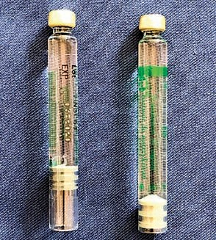

Fig. 2. Dose of 0.2 ml in an ampoule (indicatively: the thickness of the rubber stopper in the ampoule corresponds to a volume of 0.2 ml).



of the anesthetic is subject to the general applicable rules. Anesthetics without vasoconstrictors have a short duration of effect, so they are not applied in intraligamental anesthesia.

Due to the small volume of the deposited fluid, undesired general reactions are very rare. In order to

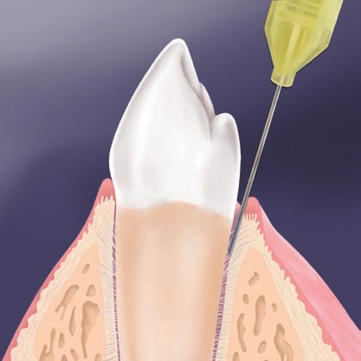

Fig. 3. Inserting the needle.

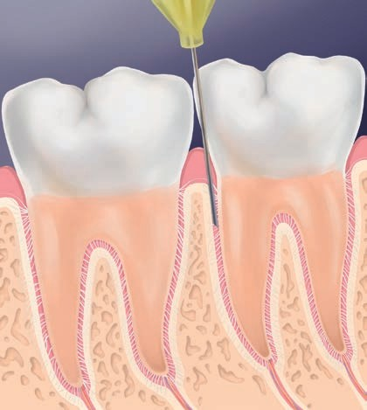

Fig. 4. Rotation of the needle towards the bone.

avoid systemic complications such as palpitations or rapid pulse, it is recommended to use anesthetics with epinephrine 1:200 000 with slow delivery. Aspiration for intraligamental anesthesia is not necessary, although the Calaject system provides automatic aspiration. For PDL anesthesia short 27 G syringes are recommended.

CCLAD step-by-step intraligamental anesthesia on the example of the Calaject device

**Before administering anesthesia:** clean the injection site. Surface anesthesia applied before intraligamental anesthesia allows to prevent discomfort during its delivery. It is recommended to probe the periodontal crevice with a periodontological probe, which enables to specify not only the depth of the periodontal crevice but also the effectiveness of the surface anesthesia.

**Positioning the needle:** we insert the needle in the interdental space at the top of the papilla to contact with the bone. In the mesiodistal space

parallel to the axis of the root, and in the vestibulo-lingual space 15-30° with respect to the axis of the root (it resembles placing the periodontal probe when examining the depth of the gingival crevice) (Fig. 3).

**Target site:** the bottom of the gingival groove (insert the needle to a depth of up to 1-3 mm).

**IMPORTANT:** Insert the needle with the pointed end down towards the root (that way we will avoid damaging the root cement).

Insert the needle until you reach the bottom of the gingival groove, observing the resistance of tissue on the control panel. Resistance on the LED display should be located at the half scale, indicating correct insertion of the needle in the periodontal space (in the case of children whose periodontal space is wider, a lower resistance is obtained on the scale). If the gingival interdental papilla is tight, move the needle away from the lingual or buccal surface of the tooth, at the same time maintaining it with the long

axis of the tooth.

When resistance of the bottom gingival groove is felt, retract the needle about 1 mm and rotate the opening towards the bone of the tooth socket wall to ensure better absorption of the anesthetic (Fig. 4).

Deposit 0.2 ml of the anesthetic solution on the tooth root. Within 20 seconds, deposit 0.2 ml at each site, making sure that whitening occurs. Delivering a larger amount of the anesthetic does not raise the effectiveness of anesthesia!

During the injection, a gentle resistance of the tissue and visible anemization/whitening of the gums should appear at the injection site.

**Symptoms of intraligamental anesthesia:** peripheral whitening of the tissue, ischemia of the marginal and attached gingiva. If no whitening appears, this may mean spillage of the fluid and the need for deeper penetration of the needle or injecting at another site.

If there is whitening and there is no effusion of the fluid from the gingival crevice, continue delivery (Fig. 5).

Retract the needle and in the case of multi-rooted teeth

repeat this step for the remaining roots.

Anesthesia occurs within 15-30 seconds and lasts for 30-60 minutes.

General recommendations for intraligamental anesthesia

1. Surface anesthesia of injection sites.
2. Inserting the needle into the gingival crevice (angle of injection like when probing the gingival crevice) until the bone level is obtained.
3. Maintaining contact between the needle and the tooth so that the penetration of the soft tissue is not too deep, especially from the lingual side.
4. Maintaining a constant, strong and slow delivery of the anesthetic (whitening should include the attached and marginal gingiva).
5. If whitening of the gingival tissues occurs and there is no effusion of the fluid, the anesthetic has been deposited successfully.
6. Do not administer a higher than recommended dose per one injection.
7. Once 0.2 ml is delivered at one site, begin administering the anesthetic at the next site of injection (ideally, once whitening of the gingival tissue in this area has already occurred).
8. Do not insert the needle again in the same spot or insert it close to the neighboring points (gingival papilla necrosis).
9. Recommended injection site for single-root teeth (1, 2) and multi-root teeth (3, 4) (Fig. 6).
10. Inserting the needle in the middle section of the lingual/buccal surface may lead to chipping or necrosis of the osseous lamina which is thin in this area.
11. The anesthetic should not be injected in infected tissue or undergoing acute inflammatory process.
12. In order to property perform intraligamental anesthesia, one should know the right injection points.

**Recommended places of injection**

Primary points:

On vestibular surfaces:

* Secant teeth - distally (Fig. 7)
* Pre-molar and molar teeth

- mesially and distally (Fig. 8 and 9)

Additional points:

When sufficient anesthesia is not achieved or during a prolonged procedure (Fig. 10).

In the case of difficulty to adjust the needle in certain areas (e.g. distally to a second or third molar), it is possible to bend the needle. Because the needle does not penetrate the tissues more than a few millimeters (1-3 mm), the bending is not as risky as the other techniques of anesthesia (Fig. 11 and 12).

Bending of the needle when administering anesthesia in the molar teeth area (Fig. 12 and 13).

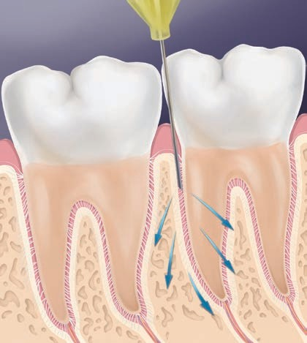

Fig. 5. Depositing the anesthetic.

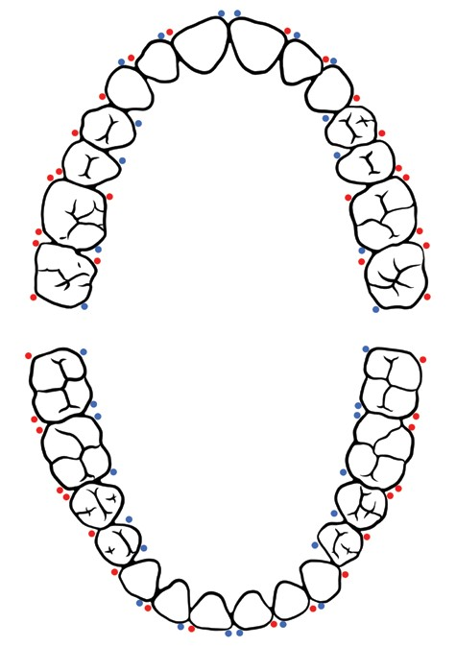

Fig. 6. Injection points with intraligamental anesthesia (diagram: red - primary points; blue - additional points).

 PRACTICAL DENTISTRY

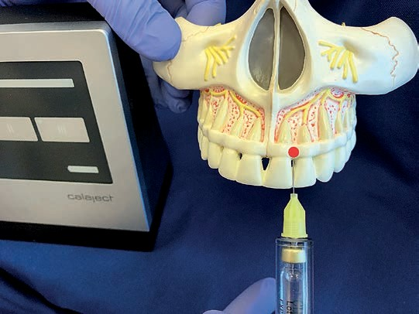

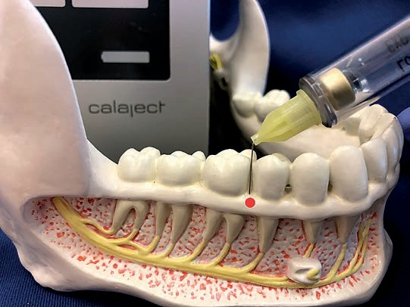

Fig. 7. Primary injection point medial secant left 21: distally.

Fig. 9. Primary injection point molar tooth 46: distally.

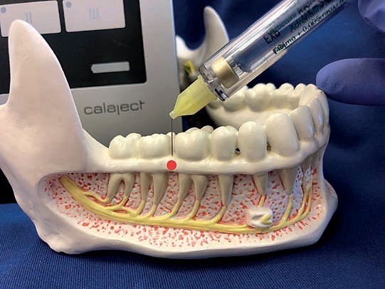

Fig. 8. Primary injection point molar tooth 46: mesially.

Fig. 10. Additional injection point molar tooth 37: mesially.

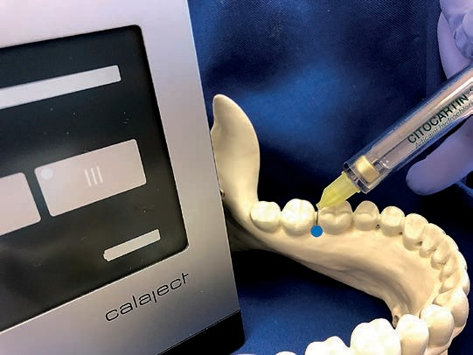

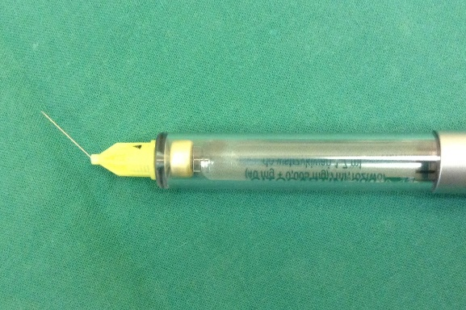

Fig. 21. Needle bending.

Advantages of PDL anesthesia using a computer system:

* 1. painless delivery thanks to the appropriate constant physiological speed,
  2. safety of tissues and lowering the risk of complications due to the pressure and tissue resistance control system,
  3. help in locating the needle in the gingival crevice based on the tissue resistance signal system,
  4. higher administration efficiency and the possibility of using lower doses - thanks to appropriate speed, the anesthetic diffuses to the bone and absorbs without flowing out of the periodontal space.

.

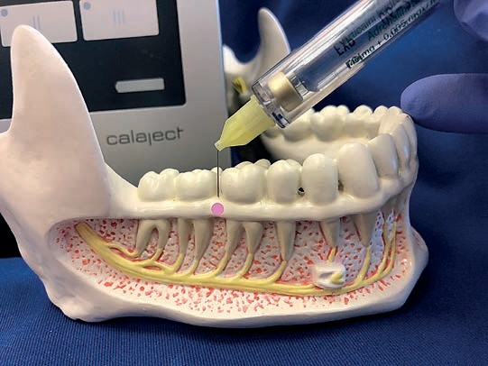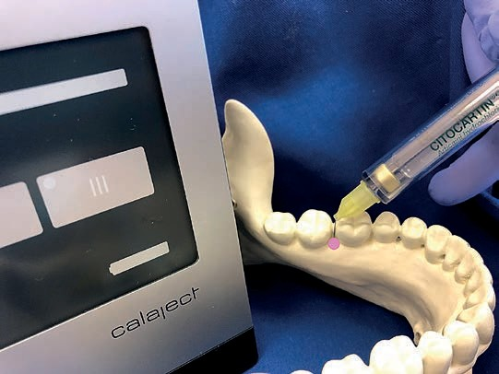

Fig. 13 Point of injection from the buccal side.

Fig. 12 Point of injection from the lingual side.

The rare post-procedural symptoms after Intraligamental anesthesia include small discomfort and tooth hypersensitivity persisting for 2-3 days when eating or increased reaction to rinsing In case these symptoms occur, use cold compresses and avoid applying any pressure of biting hard foods.

Discussion

Intraligamental anesthesia allows to achieve a level of anesthesia

that is appropriate for most clinical situations in dentistry. A number of factors determine the success of anesthesia, including clinical experience, anatomical differences,

the selection of the appropriate anesthetic, technique and tools (1, 2, 3).

The effectiveness of intraligamental anesthesia described in the literature is 58-100% depending on the type of procedure: the effectiveness is higher in periodontal procedures, surgeries and conservative dentistry than in endodontics (4).

On the basis of data from the literature, the effectiveness of intraligamental anesthesia is 58-100% (3, 4). In the studies of Kauffman et al., a 95% effectiveness was demonstrated of this anesthesia during surgical procedures and 90% during tooth pulp extraction. The analgesic effect depended on the type of the anesthetized tooth. A lower effectiveness was obtained for canines and it amounted to 49% in the studied group. This is most probably due to the length of the roots of these teeth. Secants, premolars and molars showed PDL effectiveness of anesthesia at a similar level, wherein the teeth in the maxilla showed a higher effectiveness than in the mandible, which is associated with the bone structure (5).

Johnes gives a 99% effectiveness of anesthesia performed using this method in 1688 patients (6). Based on the research carried out by Ciesielski (2002)

good efficacy of intraligamental anesthesia was found in 75% of patients (7).

The studies of most authors indicate that intraligamental anesthesia is most effective during extractions (Malamed 100% effectiveness, Miller 98.4% effectiveness) and effective with endodontic procedures (Malamed 60% effectiveness, Miller 72%

effectiveness) (3, 8).

The introduction of computer-assisted systems of injections enables to carry out intraligamental anesthesia without manually generated pressure and speed. The computer maintains a constant slow flow of the anesthetic (about 180 s for an ampoule of 1.7 ml). This is 3 times lower speed than the recommended maximum speed for other injections and it is the preferred speed for tissues like type 3 as the periodontal membrane (9). The low pressure and slow flow of fluid in the Calaject system enables to achieve a greater penetration of the anesthetic and, as a result, effective anesthesia. In addition, the low pressure and low speed of delivery often does not need the use of surface anesthesia. The advantage of using intraligamental anesthesia

Using the Calaject computer system is, among others, the controlled speed and pressure of the deposited fluid, using a small dose of the anesthetic, excluding pain centers in single teeth, preventing the dispersion of the anesthetic to neighboring teeth and surrounding tissues, as it takes place in infiltration or block anesthesia carried out using conventional methods (10).

Conclusions

The use of intraligamental anesthesia for dentistry procedures allows to achieve a satisfactory degree of analgesia, while using anesthetic on a small area of the surrounding tissue and almost no sensations of pain associated with the delivery of the anesthetic.

The introduction of computer-controlled systems of delivering anesthetics makes it possible to carry out intraligamental anesthetic at a safe speed and pressure, according to the biological characteristics of periodontal tissues and allowing to achieve a satisfactory concentration of the anesthetic around the tooth root, and as a result, a higher effectiveness of anesthesia.

n

Literature

1. QuinnC.L.:Injection to anesthetizethedifficulttooth*.* J.Calif.Dent.Assoc.,1998,26,665‑667.
2. Bassett K.B., DiMarco A.C., Naughton D.K.: Local Anesthesia for Dental Professionals*.* 2nd ed. Upper Saddle River, NJ. Pearson Prentice Hall, 2014.
3. Malamed S.F.: Handbook of Local Anesthesia. 6th ed. St. Louis, Mo. Elsevier Mosby, 2013.
4. Shira R.B.: The periodontal ligament (PDL) injection: an alternative to inferior alveolar ne‑ rve block. Oral Surg. Oral Med. Oral Pathol., 1982, 53, 117‑121.
5. Kaufman E., Weinstein P., Milgrom P.: Difficulties in achieving local anesthesia. J. Am. Dent. Assoc., 1984, 108, 205.
6. JohnsonT.M., BadovinacR.,ShaeferJ.:Teachingalternativesto the standard in ferioralveolar block in dental education: outcomes in clinical practice. J. Dent. Educ., 2007, 71, 1145‑1152.
7. Ciesielski J.: Znieczulenie śródwięzadłowe. As stomatol., 2003, 32‑33.
8. Moore P.A. i wsp.: Periodontal ligament and intraosseous anesthetic injection techni‑ ques: alternatives to mandibular nerve blocks. J. Am. Dent. Assoc., 2011, 142, 13S‑18S.
9. Clark T.M., Yagiela J.A.: Advanced techniques and armamentarium for dental local ane‑ sthesia. Dent. Clin. North Am., 2010, 54, 757‑768.
10. Ashkenazi M., Blumer S., Eli I.: Effect of computerized delivery intraligamental injec‑ tion in primary molars on their corresponding permanent tooth buds*.* Int. J. Paediatr. Dent., 2010, 20, 270‑275.